Project charter

  - Project name: Call center upgrade project

  - Date: 03.01.2020

Table of contents

Table of contents 2
Executive summary 3
Project definition 3
Project organization 3
Project plan 3
Project cost 3
Project assumptions 3
Project risks 3
Appendix 3

Version history

Provide information on how the development and distribution of the charter was controlled and tracked. Add the version number, editing date, author and the reason for the change.

Version # | Implemented  By | Revision  Date | Approved  By | Approval  Date | Reason
1.0 | <Author name> | <mm/dd/yy> | <name> | <mm/dd/yy> | <reason>

Executive summary

Write a brief summary about the project. No more than one half of a page. Include the project goal, timeline, major risks and side conditions. Remember that executives and managers are going to read this section. Therefore, make it easy to understand and avoid jargon that only insiders would understand.

Project definition

Describe in detail the project’s purpose, objectives and scope.

Include any key objectives using the SMART principle.

A well-defined objective should be:

- (s)pecific
- (m)easureable
- (a)ttainable
- (r)elevant
- (t)ime-bounded (set an end date)

Here’s an example of an objective:

“By deploying new IT infrastructure at our call center, we want to reduce waiting times for inbound customer calls by 30% by end of December <YEAR>.”

Give the reader an idea of the project’s overall impact. Specifically, the processes and areas that are going to be affected. It will be less of a surprise to people once the project is in progress:

- What processes will change?
- Which technical solutions will change?
- Will there be any disruptions to business?

Project organization

Describe the project’s organizational structure including project roles, departments and people.

Common project roles:
- project sponsor
- project manager
- steering committee

Other roles are specific to your project. Does your project have a data migration specialist, a software developer, a legal advisor or a training coordinator? Put it in here.

I’m lazy, so I usually just paste a screenshot of the project org chart here. It shows the roles, people and reporting lines at one glance

Project plan

Add here the project start date, end date and major milestones.

Also, paste a screenshot of the project plan.

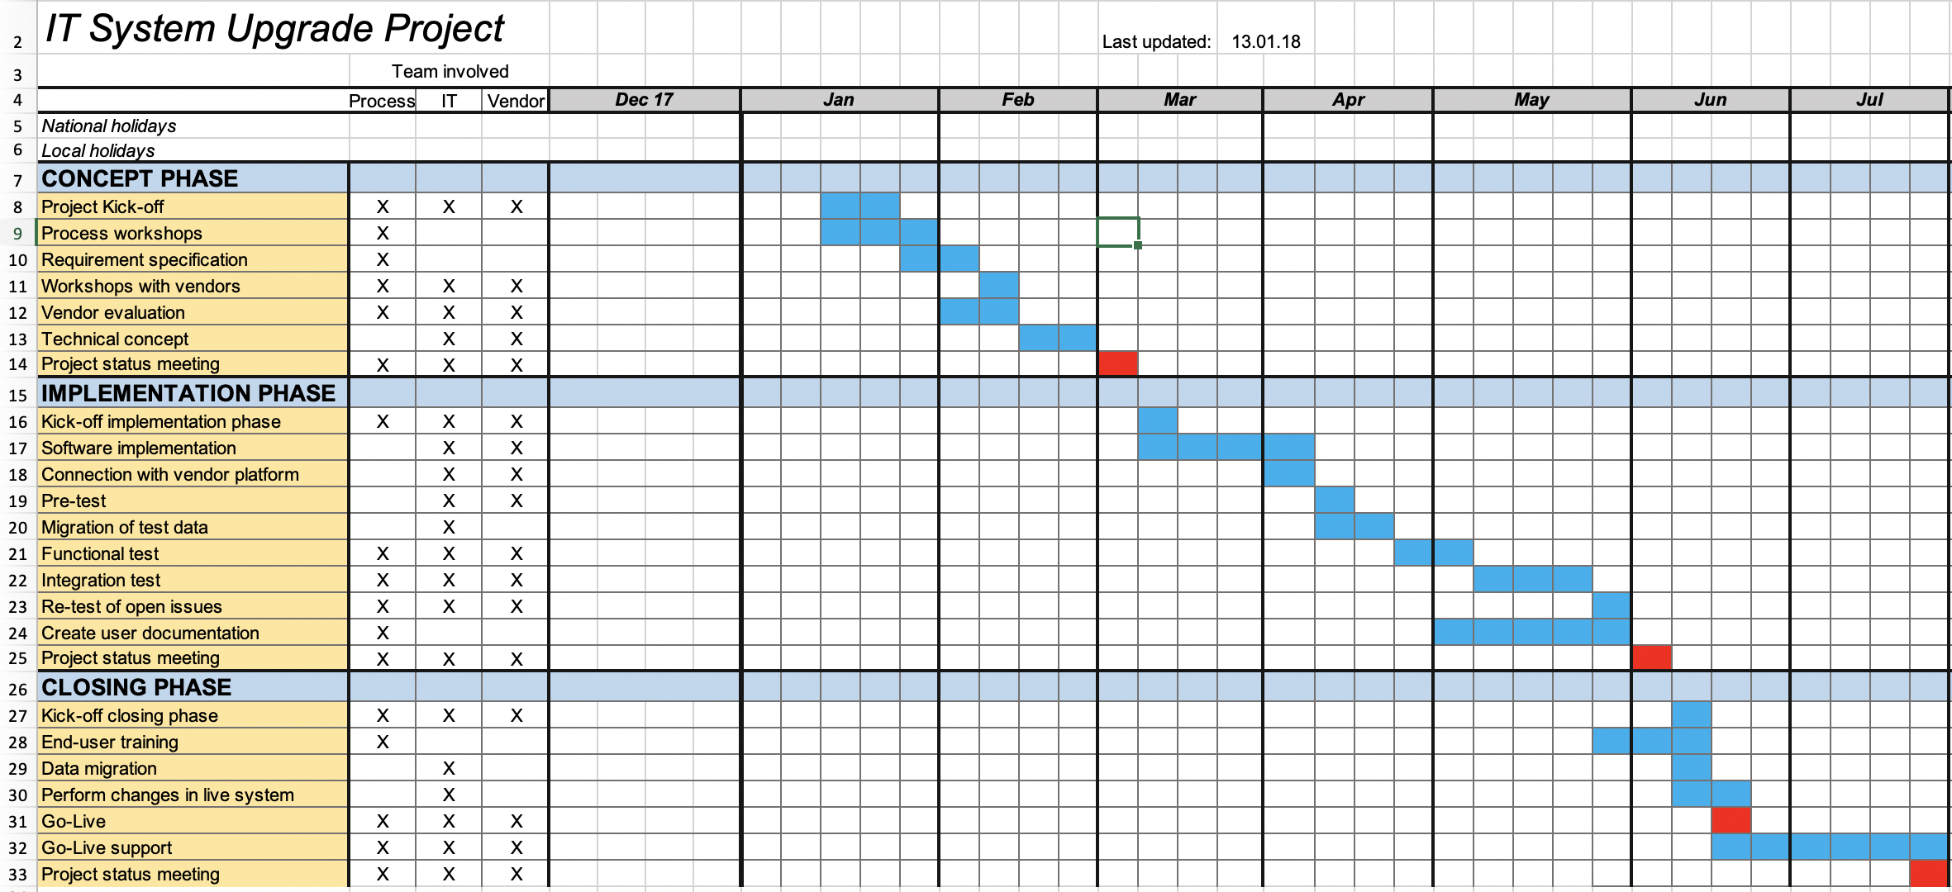

Don’t have a project plan yet? Download my project plan Excel template here and create a professional Gantt chart in minutes.

Link - project plan template:
https://www.tacticalprojectmanager.com/basics/how-to-create-project-plan-using-excel/

Project cost

I’ve seen managers skip all other sections in the charter just to read this one. It gives the estimated project cost. Managers care about the financial side more than about anything else!

Include in table form the summary figures: Total budget broken down by year or month and category such as labor, goods and services and travel cost.

Don’t know how to set up a project budget? My article on project budgeting shows you the exact steps how create a budget. Plus, you can download my budgeting template there.

I only add a screenshot of the cost dashboard here (taken from my budgeting template).

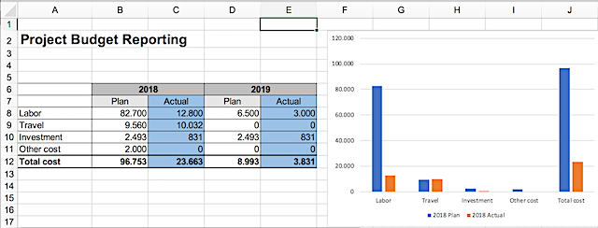

Project assumptions

Every project is based on certain assumptions. These should be listed here. It is one of the points that can save your ass later.

Here are some examples of project assumptions:
- Project activities have to be suspended in January due to a trade fair.
- The project is not responsible for checking data quality.
- The company provides capable key users who meet the defined criteria (define those here).

Project risks

What are the major risks that could jeopardize your project?

Think of technical risks such as engineering work taking longer than expected. Or resource risks, resulting in people being withdrawn for other projects, leaving you with a project but no team who can do the job. Or it could be quality risks, such as data being corrupted.

This risks section is important because it focuses people’s attention on the sensitive areas. It’s like saying “Here are the things that could mess up the project. If you are involved in any of these areas you better do your job right. Or else.”

Communicating the major risks to the customer and stakeholders also shows that you’ve done your due diligence. Nobody can blame you for not being conscious of risks.

I like to be very clear and honest in my risk assessment.

Appendix

Here you include links to project documentation or link to your original project plan, budget and other information.

Glossary

Define any abbreviations used in the project charter here.

